KODAK AUSTRALIA

Nicolas Peterson (1983) was the first to classify the various designs of postcard print papers developed by Kodak. He hoped that this would assist in dating of cards, and others have maintained his vision. However, his recent paper (2003) and other experience suggest that this is less promising than we had hoped. One part of the problem is that some of the designs have clearly been used more or less concurrently. A second difficulty is that precisely dated (postmarked or manuscript dates) are relatively unusual after the first 10 years of the century – it seems that people bought cards as souvenirs rather than a means of sending messages. Even if they did post them to friends, they were often enclosed in envelopes and so remained undated.

I have also explored the possibility of finding some record in the archives of Kodak Australia, but it seems clear that no such records have been retained. But in the course of my inquiries, Don Pitkethley was good enough to suggest that the differences may have provided a code to distinguish manufacturing or marketing batches. A quick overview of my own collections does show there are some differences in geographical distribution, which supports Don’s suggestion. I intend to review this once I complete a current upgrading of my own catalogue. In the meantime, it is clearly worth trying to at least further develop an inventory of designs.

Essentially, distinguishing between the various forms depends upon the detail of the stamp box. I have added considerably to Nic’s original categories, and so list these below, together with the range of dates known to me.
First of all, let me summarise the various types:

Peterson  (1983) | Proposed new listing

Symbols in all four corners
K-A | K-A
 | K-A1
K-D | K-D
K-G | K-G
 | K-H

Symbols in three corners
 | K-A2
K-C | K-C
 | K-C1
 | K-C2

Symbols in two corners
K-B | K-B
 | K-B1
K-E | K-E

Symbol in one corner only
K-F | K-F
 | K-F1

Now we can turn to a description of each category.

Symbols in all four corners

K-A  Use recorded from 23.i.1908 to 23.iv.21.  Ornate scroll work; solid dots in all corners | 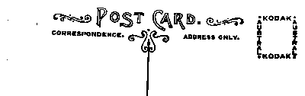

K-A1  Use recorded 1913-27.i.14  No scroll work; solid dots in all corners | 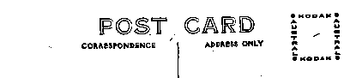

K-D  Small crosses in all corners  Use recorded from 29.v.14 to as recently as 1948. The most prevalent type. | 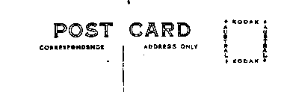

K-G  Note: difference lies in use of word Kodak on all 4 sides of stamp box. | 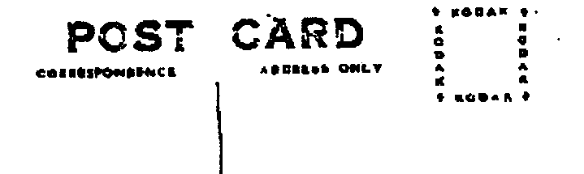

K-H  (c. 1946>)  Solid 5-point stars in all corners | 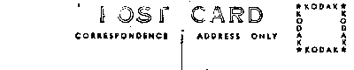

Symbols in three corners

K-A2  Ornate scroll work; solid dots in corners  1,2,3 | 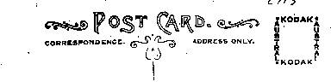

K-C  Use recorded 13.i.25  Small crosses in corners 1, 2 & 4 only | 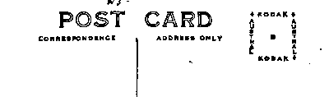

K-C1  Small crosses in corners 2, 3 & 4 only | 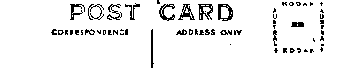

K-C2  Small Crosses in corners 1,3 & 4 only | 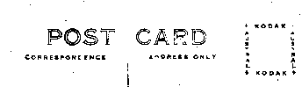

Symbols in two corners

K-B Use recorded 21.xii.23-12.ii.29  Small crosses in corners 2 & 4 only | 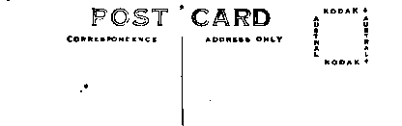

K-B1
Small crosses in corners 1 & 3 only

K-E  Small crosses in corners 3 & 4 only | 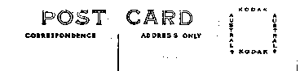

Symbol in one corner only

K-F  Use recorded from 27.viii.26-3.i.31  Small cross in corner 2 only | 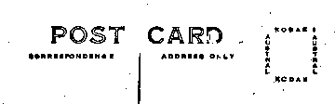

K-FF  Small cross in corner 1 only | 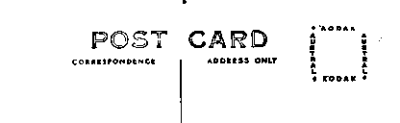

Regrettably, although I have seen an example, I do not have a copy of K-B1 available in my own collection.

In addition to this overview, numbers or letters may also appear in the centre of the stamp box and in due course, an analysis of these may also be useful. Those that I have recorded so far are:

K-B 5, 22
K-C A, B
K-D 1, 2, 3, 4, 5, 7, 8, 9, 10, 11, 12 14, 15, 16 20, 22
A, B, F, G, H N, M S, T, U, V, W, X, Z

Just as a footnote of interest, most people probably assume that the words Kodak Austral are simply an abbreviation of Kodak Australia – but it is a bit more complex. For many years, Baker and Rouse were the Australian agents for Kodak, and at the same time, manufactured photographic equipment and supplies under the trademark of Austral. So, when Kodak decided to extend their own operation to Australia, they took over Baker and Rouse and integrated them into their own company structure.

Elery Hamilton-Smith, AM
P.O. Box 36, Carlton South, Victoria 3053. elery@alphalink.com.au

